Ontology Report Artificial Intelligence and Machine Learning

Rui Filipe Santos Carapinha 248728

1. **Pizza Tutorial**

In this part I was able to do everything it. I just had one or another issue that I could solve after a little research.

The result of the ontology was the following:

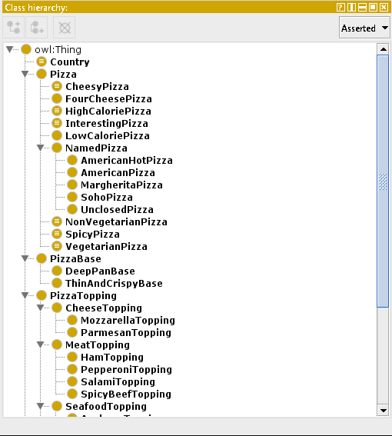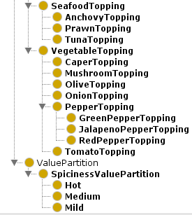

For the DL Query part, the results I obtained were the following:

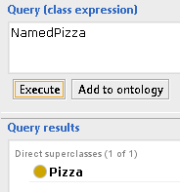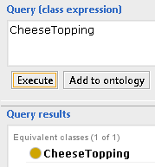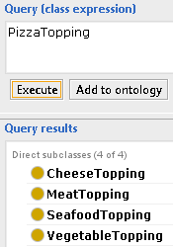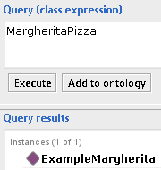

In the SPARQL Query tab, the exercises are the following:

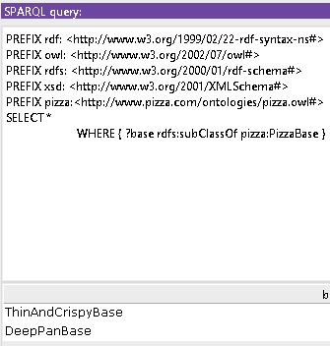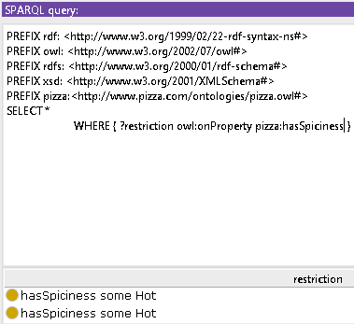

1. **FOAF Ontology**

FOAF ontology let you create a machine-readable ontology describing anything, like persons in this case.

I used the FOAF Ontology to create a profile about me with my name, cellphone, favorite sports, etc.

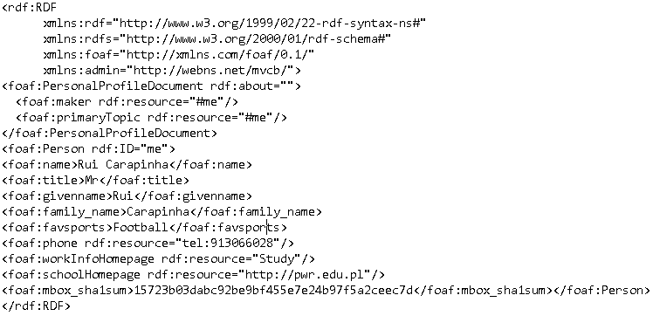The profile I built using FOAF Ontology was the following:

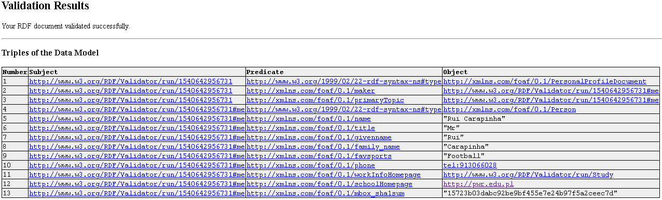The result of the RDF Validator was the following:

I didn’t place the N3 and RDF files in a web page because I don’t own any.

Using DL and SPARQL Query, I got the following results:

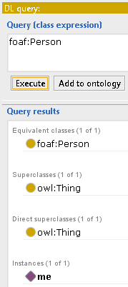

1. **Published Ontology**

The ontology I chose was a movie ontology (<https://github.com/ontop/ontop/wiki/Example_MovieOntology>). This ontology has information such as title, genre, director, actor, prizes, etc.

The DL Query I made was the following:

